**Assignment No.5**

Name: - Bhavin Ratansing Patil

Roll No.: - 26 SEDA

**Que 1. Create the following database with appropriate constraints using DDL and populate/modify it with the help of DML. Use alter table command to modify table schema. Use Primary Key, Foreign Key, Not Null, Unique, etc.**

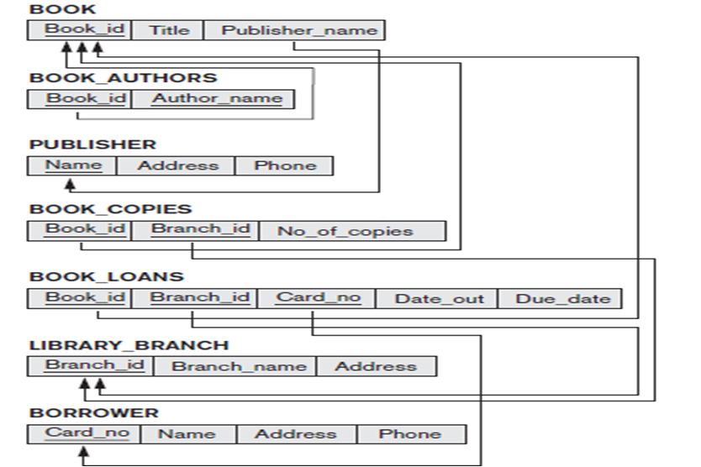

**Creating Tables:**

**PUBLISHER table:**

create table PUBLISHER (Name varchar2(10), Address varchar2(20), Phone number(10), PRIMARY KEY(Name));

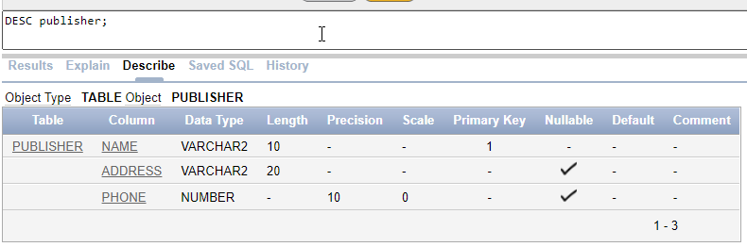

**BOOK table:**

create table BOOK(Book_id number(3) Primary Key, Title varchar2(10) NOT NULL, Publisher_Name varchar2(10), FOREIGN KEY(Publisher_Name) REFERENCES PUBLISHER(Name));

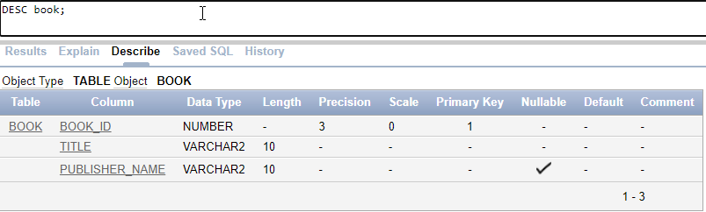

**BOOK_AUTHOR table:**

create table BOOK_AUTHOR (Book_id number(4), Author_Name varchar2(10), FOREIGN KEY(Book_id) REFERENCES BOOK(Book_id));

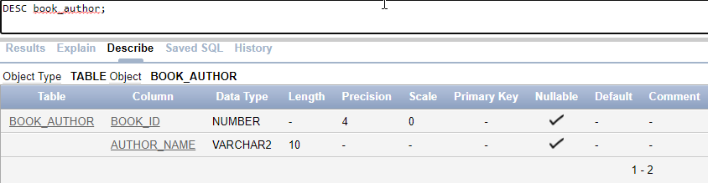

**BOOK_COPIES table:**

create table BOOK_COPIES (Book_id number(3), Branch_id number(10),No_of_copies number(10), CHECK (No_of_copies >=10), FOREIGN KEY(BOOK_ID) REFERENCES BOOK(Book_id));

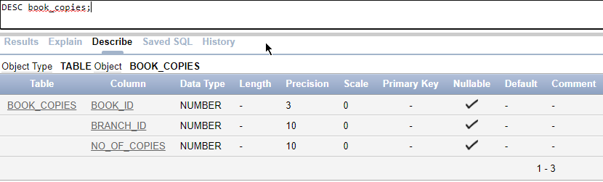

**BOOK_LOANS table:**

create table BOOK_LOANS (Book_id number(3), Branch_id number(10), Card_no number(10) UNIQUE , Date_out date, Due_date date, FOREIGN KEY(BOOK_ID) REFERENCES BOOK(Book_id) );

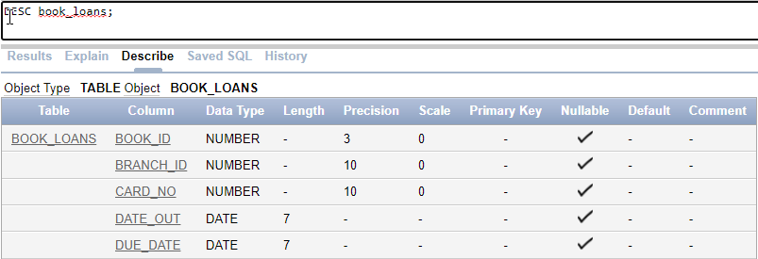

**LIBRARY_BRANCH table:**

create table LIBRARY_BRANCH ( Branch_id number(10) PRIMARY KEY, Branch_Name varchar2(20), Address varchar2(20) );

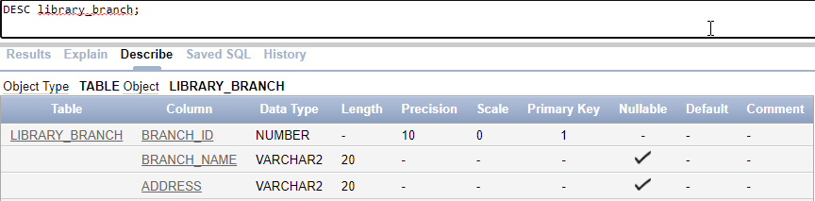

**BORROWER table:**

create table BORROWER (Card_no number(10) PRIMARY KEY, Name varchar2(10), Address varchar2(20), Phone number(10));

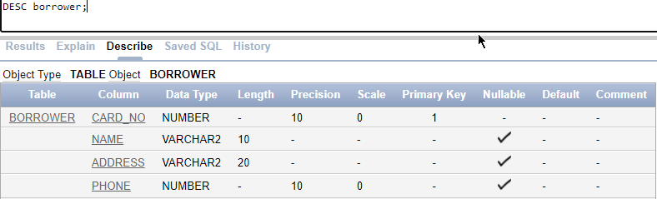

**Altering Tables:**

**Alter BOOK_COPIES to make branch_id as foreign key:**

alter table BOOK_COPIES add (FOREIGN KEY(Branch_id) REFERENCES LIBRARY_BRANCH (Branch_id));

**Alter BOOK_Loans to make branch_id as foreign key:**

alter table BOOK_LOANS add (FOREIGN KEY(Branch_id) REFERENCES LIBRARY_BRANCH (Branch_id));

**Alter BOOK_Loans to make Card_no as foreign key:**

alter table BOOK_LOANS add (FOREIGN KEY(Card_no) REFERENCES BORROWER (Card_no));